Comparing definitions from Strong's, Gesenius, and the 1524 Bomberg MT with the contextual definitions from the KJV English.

Psalms 22:16
For dogs have compassed me: the assembly of the wicked have inclosed me: they pierced^{H3738 H738} my hands and my feet.

Hebrew Word | Transliteration | Literal Masoretic Meaning | KJV Rendering
כִּי | kî | For / Because | For
סְבָבוּנִי | sĕbābûnî | they have surrounded me | have compassed me
כְּלָבִים | kĕlābîm | dogs | dogs
עֲדַת | ‘ădaṯ | assembly/congregation of | the assembly of
מְרֵעִים | mĕrē‘îm | evil-doers | the wicked
הִקִּיפ֑וּנִי | hiqqîpûnî | they have enclosed me | have inclosed me
כָּאֲרִי | kā’ărî | like a lion | they pierced
יָדַי | yāḏay | my hands | my hands
וְרַגְלָֽי | wĕraḡlāy | and my feet | and my feet

This first example is a great starting point for many reasons.

The MT literally reads “like a lion” instead of what we see in the English which is “they pierced”. This is the only place in the entire Bible that you will find H738 translated as something other than a form of “lion”.

Take special note that in the MT itself the Hebrew word(s) for “pierced”, “bore”, or “dig” DO NOT appear. So, where did the KJV translators get the idea that this noun (lion) should instead be translated into a verb? Purportedly, they got it from the same place every one else got it: from the marginal notes of the scribes of the Masorah, ancient manuscripts, and other translations.

The key difference here is in the interpretation and subsequent definitions given.

Gesenius:

1. כּוּר a root of doubtful authority in the verb, but signifying as far as can be gathered from its derivatives, TO DIG, TO BORE THROUGH, like the kindred roots נָקַר ,קוּר ,אָכַר ,קָרָה. Compare Arab. כּוּר a digging in the earth, and in the Indo-Germanic languages, Sanser. khûr, to cleave, to dig. Hence מַכְאֵרָה μάχαιρα, a sword, so called from its piercing, executioner, also מְכוּרָה ,מִכּוֹרָה a place where metals are dug, hence native place.

Very many interpreters suppose the verb itself to be found in a passage much discussed as relating to the Messiah [see the note], Ps. 22:17, where David, pursued by the soldiers of Saul, says, "Dogs have surrounded me, the assembly of the wicked have inclosed me כָּאֲרִי יָדַי וְרַגְלָי." To give my own opinion, I now regard it as the most simple exposition to retain the ordinary signification of the words, and to translate "as lions" they gape upon, or threaten [this would be a strange ellipsis], "my hands and my feet," i. e. they threaten to tear all my members. The form כָּאֲרִי is ὡς ὁ λέων, i. e. as lions, like Isaiah 38:13; and to threaten, to gape upon, or a similar verb may be understood in this member of the sentence from the foregoing context, by the ordinary figure zeugma.

However, all the ancient interpreters have taken כָּאֲרִי as a verb, and this may be defended, if we regard it as a participle of Kal, formed in the Chaldee manner (כָּארִים part. כָּארִי and plural, for כֹּארִים): כָּאֲרִי for כָּארִים although it would be cause for surprise if we were to find two grammatical forms of such extreme rarity joined in one word (compare Lehrg. 401, 523). If this opinion were adopted, we should render, piercing, digging through, my hands and my feet, that is, my enemies (who are to be understood by the dogs) with their darts and weapons on every side: and there is no need to remark that even these things apply as suitably as possible to David, to whom this psalm is ascribed in the title, and that at least there is no need to understand them of Christ as affixed to the cross.

A verb of piercing in the sense of wounding (compare כּוֹר and Arab. חָוַר to perforate, to wound) is most aptly applied to hostile weapons; and hands and feet are used poetically for all the members and the whole body (compare Hesiod. 114). LXX. ὤρυξαν (the verb which they use elsewhere for כָּרָה). Vulg. foderunt. Aqu. Symm. in the Hexapla and Jerome (according to the reading vinxerunt [which is a mere erratum]) give the word the signification of binding, tying, which is defensible on philological grounds (and this ought not to have been denied by Hengstenberg, Christologie d. A. T. i. p. 180 compare Arab. כּוּר to fold round a head-dress, a wreath, a head-dress, but it is much less suitable to the context. — Aquila in his first edition ᾔσχυναν, they disfigured, i. e. they stained with blood, prob. ascribing to the root כּוּר the signification of the Aramean כְּאַר. Farther, that כָּאֲרִי was commonly regarded as a verb is shown by the reading of two MSS. (כָּאֲרוּ) כָּאֲרוּ for כָּאֲרִי.
- Gesenius has great difficulty with the interpretation for Psalm 22:16 and he assumes it is a mistake and attempts to correct it with a literal only definition.
  - In doing so, he ascribes the events to only David and dismisses any association with Jesus Christ.
    - He then is also forced to reconcile the “hands and feet” part which he says is simply poetically referring to the “whole body”.
  - 1 Peter 1:10-12, 2 Peter 1:21 make it crystal clear that the Holy Ghost is none other than the Spirit of Christ that spoke through the prophets (Acts 2:29,30) which testified beforehand of the sufferings of Christ.

Strong's:

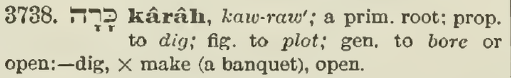
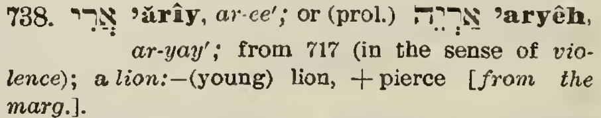
- The MT reads literally “like a lion” (H738) but Strong's added H3738 to signal to us the same meaning implied by the scribes of the Masorah in their marginal notes: and that is that “lion” here is not used as a noun but instead as a verb.
- Strong’s not only agrees with the KJV translators (and the English), but he also doesn’t question the authority or interpretation of what could be a very difficult translation without the Holy Ghost.

Isaiah 7:14
Therefore the Lord himself shall give you a sign; Behold, a virgin^{H5959} shall conceive, and bear a son, and shall call his name Immanuel.

Gesenius:

עַלְמָה f. of the preceding, a girl of marriageable age, like the Arab. غلامه and Gr. νεᾶνις (by which word Hebrew is rendered by the LXX. Ps. 68:26 and Aqu., Symm., Theod., Isa. 7:14), Gen. 24:43; Ex. 2:8; Prov. 30:19; Cant. 1:3; 6:8. Used of a youthful spouse recently married, Isa. 7:14 (compare נַעֲרָה [see note at the end of the art.] The notion of unspotted virginity is not that which this word conveys, for which the proper word is בְּתוּלָה [betulah] (compare Cant. 6:8, and Prov. loc. cit.; so that in Isa. loc. cit. the LXX. have incorrectly rendered it παρθένος); neither does it convey the idea of the unmarried state, as has of late been maintained by Hengstenberg, (Christol. des A. T. ii. 69), but of the nubile state and puberty. See Comment. on Isa. loc. cit.—עַל־עֲלָמוֹת in the manner of virgins, nach Jungfrauen Weise (see No. 1, ג, ג), i. e. with the virgin voice, sharp, Germ. soprano, opp. to the lower voice of men, 1 Ch. 15:20 (see as to this passage under the root עוּן No. 1 Piel); Ps. 46:1. Forkel (Gesch. der Musik, i. p. 142) understood it to mean virgin measures (compare Germ. Jungfrauenweis), but this does not suit the context, in 1 Ch. loc. Cit.
- There’s no other way to put this other than it’s Gesenius showing his fundamental lack of understanding of the Hebrew language.
- The root of H5959 עַלְמָה (ʿalmāh) is עָלַם (ʿālam), which means to hide, conceal, or cover. It’s not just simply a young woman, it is one that has been hidden, concealed, or chaste. It is more specific than H1330 בְּתוּלָה.
  - If we use Gesenius’s definition in the context of Isaiah 7:14 would there be anything special about the sign (miracle) that the Lord would give?
- The Hebrew עַלְמָה (ʿalmāh) was translated as some form of “virgin” in five places: Gen 24:43, Pro 30:19, Sos 1:3, 6:8, Isa 7:14 which according to Gesenius is “incorrectly rendered”. In other words, he’s accusing God of not keeping His promise (Psa 12:6,7).

Strong's:

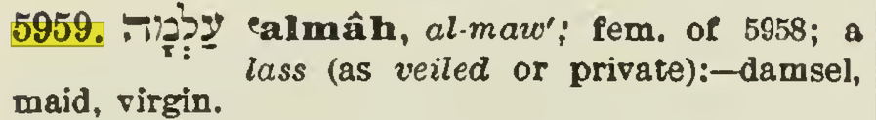

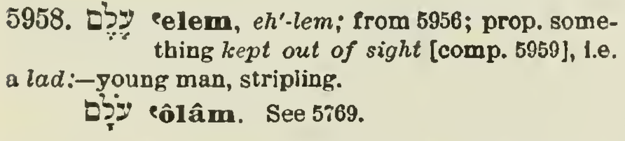
- Strong's definition is spot-on and lacks any of the casting of doubt that Gesenius’ entire book is rife with.

Psalms 9:17
The wicked shall be turned into hell^{H7585}, and all the nations that forget God.

Gesenius:

שְׁאוֹל f. (once m. Job 26:6; i. q. שֹׁאָה Isa. 5:14; 4:9); orcus, hades, a subterranean place, full of thick darkness (Job 10:21, 22), in which the shades of the dead are gathered together (עֲמָקִים which see), and to which are attributed both valleys [rather depths] (Pro. 9:18) and gates (Isa. 38:10); Gen. 37:35; Num. 16:30, seqq., Psa. 6:6; Isa. 14:9, seqq., 38:18; Eze. 31:16, seqq., 32:21, seqq. (Syr. שְׁיוֹל f. and Eth. סיול : hell, purgatory, limbus Patrum.) I think that I have lighted on the true etymology of the word. For I have no doubt that שְׁאוֹל is for שֹׁעַל a hollow, a hollow and subterranean place, just as the Germ. Hölle is of the same origin as Höhle, and Lat. cælum is from the Gr. κοῖλος, holl, hollow. It is commonly derived from the idea of asking, from its asking for, demanding all, without distinction; hence orcus rapax, Catull. ii. 28, 29.
- Associates Sheol with “orcus/orcus rapax” (latin for the Roman god of the underworld).
- Describes the inhabitants as “shades” (mythological ghosts).
- Defines hell as a hollow, subterranean place.
- His definition might be correct if it wasn’t for the mixing of theologies. And when we look at the language he uses elsewhere it becomes clear that his theology is that of Roman/Classical/Greek mythology and more importantly that he is adapting the MT to his theology instead of the other way around.

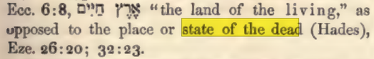

Hell is a “state” and not a literal place where those who reject Christ suffer endless torment while they await the great white throne judgment after which they will be thrown into the lake of brimstone and fire.

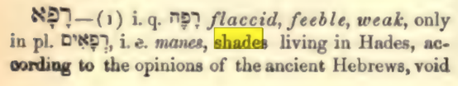

“shades living in Hades” (shades is from the latin umbrae which means “shadow”).

Strong's:

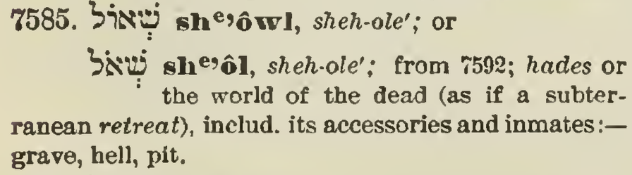
- Strong’s uses an appropriate word to describe the conscious inhabitants of hell: inmates (Isaiah 61:1, Luke 4:18,19).

Isaiah 34:7
And the unicorns^{H7214} shall come down with them, and the bullocks with the bulls; and their land shall be soaked with blood, and their dust made fat with fatness.

Hebrew Word | Transliteration | Literal Masoretic Meaning | KJV Rendering
וְיָרְדוּ | wə-yā-rə-ḏū | And shall come down | And shall come down
רְאֵמִים | rə-’ê-mîm | unicorns | unicorns
עִמָּם | ‘im-mām | with them | with them,
וּפָרִים | ū-p̄ā-rîm | and bullocks | and the bullocks
עִם | ‘im | with | with
אַבִּירִים | ’ab-bî-rîm | bulls | the bulls;
וְרָוְתָה | wə-rā-wə-ṯāh | and shall be soaked | and shall be soaked
אַרְצָם | ’ar-ṣām | their land | their land
מִדָּם | mi-dām | with blood | with blood,
וַעֲפָרָם | wa-‘ă-p̄ā-rām | and their dust | and their dust
מֵחֵלֶב | mê-ḥê-leḇ | from fatness | made fat with fatness.

First edition 1611 Holy Bible:

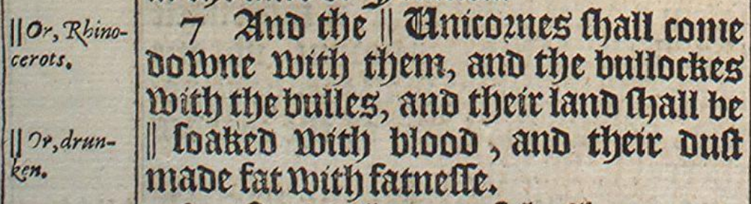
- In 1611 “Unicorn” (Latin: “unus cornu”/”unicornus” or “one horn”) was the common term for any animal with one horn.
- In 1611 “Rhinocerots” (Greek: “rhis keras” or “nose horn”) was a scholarly, foreign, technical term. It follows the plural form of the Greek rhinokerotos which is now commonly known as simply “Rhinoceros” (see Rhinoceros unicornis).
- In the margin the KJV translators left a note that is a deliberate aid for the reader to understand their translation choice: the creature has one horn

Gesenius:

רְאֵם Nu. 23:22; Job 39:9, 10; רְאֵים Psa. 92:11; רֵים Psa. 29:6; also רֵמִים Psa. 22:22; m. a wild animal, fierce and untamed, resembling an ox, as a wild ass resembles an ass (Job loc. cit. Deut. loc. cit. comp. Isa. 34:7; Ps. 29:6, where the calf is parallel to בֶּן-רְאֵמִים); possessed of horns, with which it prostrates every thing (Deut.), and injures men (Psalm 22:22 [but this is figurative]). The animal meant is doubtful; I have no hesitation in agreeing with Alb. Schultens, Job loc. cit. and de Wette on Psalm 22:22; in understanding it to be the buffalo. The Arabic word, indeed, which answers to this ريم denotes a large and fierce species of antelope (Oppian. Cyneget. ii. 445), a meaning which has also been assigned to the Hebrew word by Bochart (Hieroz. i. p. 948, seqq.), Rosenmüller and others; but whatever they say, every one must see that it is much more suitable to compare the buffalo with the ox than the antelope; (of these animals there is an excellent collection in the Zoological Museum at Berlin). The usage of the Arabic language, therefore, in this word, as is often the case, resembles the Hebrew without being altogether identical; and the larger antelopes appear to have acquired the name of buffaloes in Arabic, just as they are called in Greek βούβαλος, βουβαλίς, and just as the Arabs call animals of the deer kind البقر الوحشى wild bulls—LXX. rendered it μονοκέρως, Vulg. unicornis, an animal described by Pliny (H. N. viii. 21) which has been long considered by naturalists (especially since the time of Buffon) as fictitious and fabulous; but English travellers have of late found it in the deserts of Thibet (see Rosenmüller's Morgenland, ii. p. 269 seq.; Quarterly Review, No. 47). But this interpretation cannot be admitted, as the unicorn is more like a horse than an ox, and also is a very rare animal, while the Rêm, as appears from the passages cited, is common enough in Palestine and the neighbouring regions.
- Psalm 22:22 is not the correct reference (it’s Psalm 22:21).
- Regardless, according to Gesenius this Hebrew word means “a buffalo”.
  - Do buffalo have one or two horns?
- Additionally, if you read the last section on unicornis carefully, Gesenius believes that the “unicorn” being referenced is the same mythological horse creature of fantasy. “and also is a very rare animal” implies that he also believed that the mythological creature exists.

Strong's:

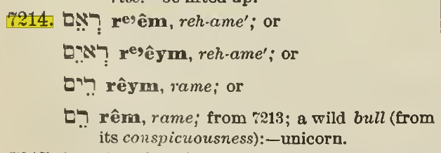
- Strong's defines “רְאֵמִים" as “a wild bull” which unfortunately disagrees with the English and therefore is also in error.

Bulls and buffalo typically have two horns and if רְאֵמִים actually meant “buffalo” or “wild bull” the grammar elsewhere like Psalm 91:10 would be incorrect:

Psalms 92:10
But my horn shalt thou exalt like the horn of an unicorn: I shall be anointed with fresh oil.
- Notice that both are singular “horn”.

You won’t find the plural “horns” used with the singular “unicorn” anywhere in the Holy Bible because, as the name itself and the context of every usage implies, it’s a one-horned creature.
Noah Websters 1828:

U'NICORN, n. [L. unicornis; unus, one, and cornu, horn.]
1. an animal with one horn; the monoceros. this name is often applied to the rhinoceros.
2. The sea unicorn is a fish of the whale kind, called narwal, remarkable for a horn growing out at his nose.
3. A fowl.
fossil unicorn, or fossil unicorn's horn, a substance used in medicine, a terrene crustaceous spar.

The etymology of the English word itself is sufficient to define itself via it’s composition alone (Latin: “unus cornu”). It’s simply Latin for “one horn” and there is no way around that.

- Monokeros (Greek)
- Unicornus (Latin)
  - Uni – a prefix derived from unus (one)
  - Cornis – derived from cornu (horn)
- Unicorne (Old French)
- Unicorn (Middle English)

Isaiah 14:12
How art thou fallen from heaven, O Lucifer^{H1966}, son of the morning! how art thou cut down to the ground, which didst weaken the nations!

Hebrew Word | Transliteration | Literal Masoretic Meaning | KJV Rendering
אֵיךְ | ’êḵ | How | How
נָפַלְתָּ | nā-p̄al-tā | art thou fallen | art thou fallen
מִשָּׁמַיִם | miš-šā-ma-yim | from heaven, | from heaven,
הֵילֵל | hê-lêl | shining one / Lucifer | O Lucifer,
בֶּן-שָׁחַר | ben-šā-ḥar | son of the morning! | son of the morning!
נִגְדַּעְתָּ | niḡ-da‘-tā | art thou cut down | art thou cut down
לָאָרֶץ | lā-’ā-reṣ | to the earth, | to the earth,
חוֹלֵשׁ | ḥō-w-lêš | which didst weaken | which didst weaken
עַל-גּוֹיִם | ‘al-gō-w-yim | the nations! | the nations!

Part | Hebrew | Meaning
Prefix/Stem | הֵי (Hê) | This indicates the causative or intensive "shining."
Root | יָלַל / הָלַל | To shine / To boast / To cry out.
Full Word | הֵילֵל (Hê-lêl) | The Shining One / The Boaster.

First edition 1611 Holy Bible:

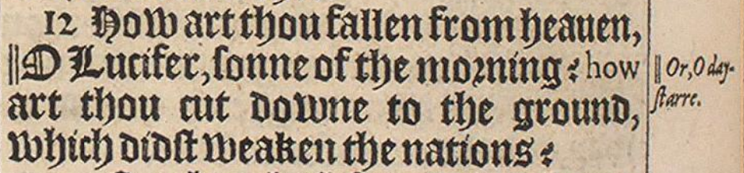
- Marginal note: “Or, day-star”

Gesenius:

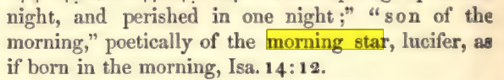

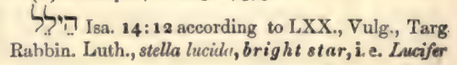
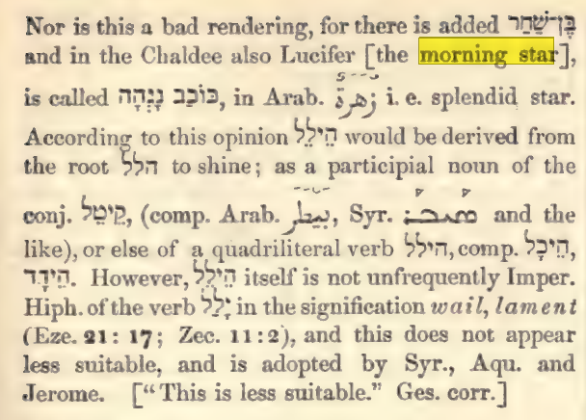
- Completely ignores the context, the prophecy, and the literal connection to Satan.

Strong's:

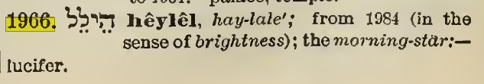
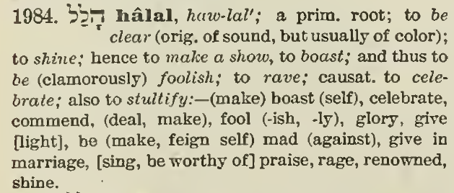
- It looks like Strong also copied the same error. While הֵילֵל does mean to shine, to boast, or to cry out (in the sense of brightness) using “morning-star” for the definition is a very poor choice because it not only contradicts the Bible but it also gives a title to someone to whom it does not belong.

Revelation 22:16
I Jesus have sent mine angel to testify unto you these things in the churches. I am the root and the offspring of David, and the bright and morning star.

- New International Version (NIV): "morning star"
- English Standard Version (ESV): "day star"
- New American Standard Bible (NASB): "star of the morning"
- New Revised Standard Version (NRSV): "Day Star"
- Holman Christian Standard Bible (HCSB): "shining morning star"
- The Living Bible (TLB): "bright morning star"
- New Living Translation (NLT): "bright morning star"
- Good News Translation (GNT): "bright morning star"
- Christian Standard Bible (CSB): "shining morning star"
- Revised Standard Version (RSV): "Day Star"
- New King James Version (NKJV): While it keeps "Lucifer" in the text, it often includes a marginal note suggesting "morning star," thereby giving place to the error of the modern critics.

Are you ok with someone claiming that “Lucifer” is the same as “Jesus”?

Proverbs 18:24
A man that hath friends must shew himself friendly^{H7489}: and there is a friend that sticketh closer than a brother.

Hebrew Word | Transliteration | Grammatical Breakdown | Literal Masoretic Meaning | KJV Rendering
אִישׁ | ’îš | Noun | A man | A man
רֵעִים | rê-‘îm | Noun (Plural) | of friends | [that] hath friends
לְהִתְרֹעֵעַ | lə-hiṯ-rō-‘ê-a‘ | Prep. + Verb (Hithpoel) | to be broken / to perish | must shew himself friendly:
וְיֵשׁ | wə-yêš | Conj. + Particle | and there is | and there is
אֹהֵב | ’ō-hêḇ | Noun | a friend | a friend
דָּבֵק | dā-ḇêq | Verb / Adj. | that sticks | [that] sticketh
מֵאָח | mê-’āḥ | Prep. + Noun | than a brother | closer than a brother.

Gesenius:

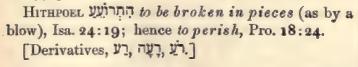
- Not a terrible definition.

Strong's:

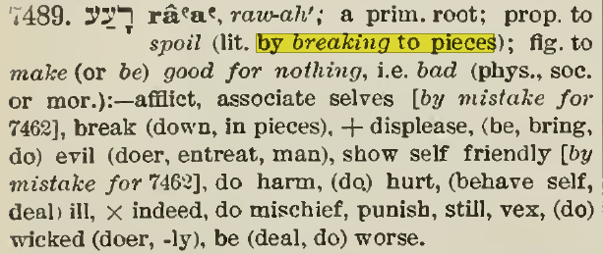
- In two places Strong’s says “by mistake for H7462”. In other words, this word is wrong and should be replaced with H7462. This is yet another accusation that God didn’t keep His promise in Psalm 12:6,7. Changing the word would completely ruin the proverb (pun intended).

A contextual analysis of the 1524 Bomberg Masoretic Text for Proverbs 18:24 reveals that the first clause is contrasting a man with many casual relationships to the second clause which is a singular intimate relationship. In doing so it also highlights the value of quality over quantity in relationships.

A man that hath friends must shew himself friendly | Having many casual relationships will lead one to ruin
and there is a friend that sticketh closer than a brother | Focusing on your singular relationship with God

